**Daily Scrum or Standup Meeting**

Team name: Group 2

Scrum Master: Max Edwards

Date:_______________March 28________________

| **Team Member** | **What did you do since the last scrum?** | **What do you plan to do before the next scrum?** | **What obstacles do you have?** |
| --- | --- | --- | --- |
| Satchell Fausett | Nothing | Film videos | Time |
| Jared Hansen | Helped debug  Powerpoint slides | 1 slide recording of reservation use case | Internship |
| Chase Miller | Powerpoint slides | Requirement 3 | NSA wants to find him |
| Max Edwards | Debug | Website maintenance  Send Jared React router | Time |
|  |  |  |  |

# Burndown

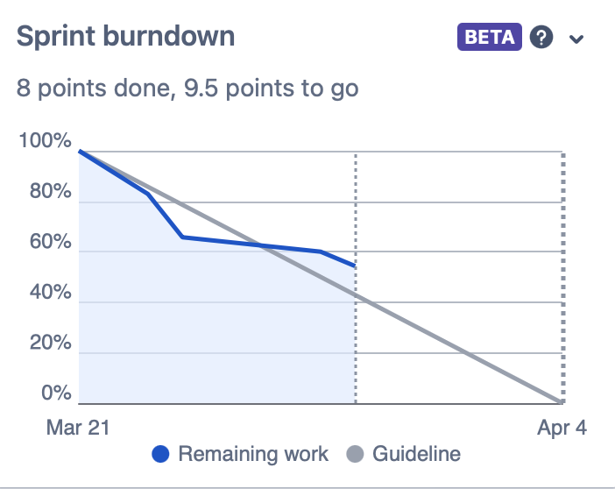

# Screenshot of you project board

